# Data Centric RAD

## Lab 7 JDBC

### Part 1 Setting up a JDBC Project

* Open Eclipse Java EE IDE for Web Developers.
* Select *File/New/Other…*
* When the dialog box opens, select *Java Project*.
* Give the Project a *Name* and press *Finish*.
* In the Windows File Explorer, navigate to the project you just created and create a folder called *lib*, so that your project now looks as follows:

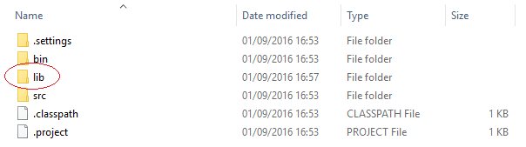

* Download the MySQL driver from <https://dev.mysql.com/downloads/connector/j/>.
* After unzipping the file, copy mysql-connector-java-5.1.39-bin.jar to the *lib* folder previously created.
* Press F5 to refresh Eclipse.
* In Eclipse, select the project you just created and then select *Project/Properties*.
* Click on *Java Build Path*, then the *Libraries* tab, then press the *Add JARs…*
* Select the mysql-connector-java-5.1.39-bin.jar file in the lib directory of the project and press *Open.*
* When the mysql-connector-java-5.1.39-bin.jar appears on the build path (see below) press OK.

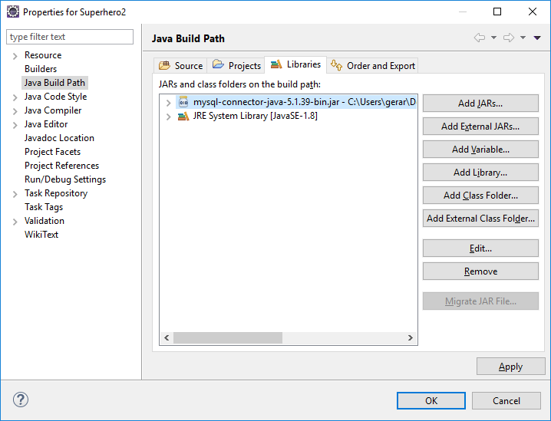

* In Eclipse, click on the *src* folder and select *File/New/Class*.
* Enter a Package name, and a Class name. Press *Finish*.
* At the top of the Class just created type the following:

**import** java.sql.Connection;

**import** java.sql.Statement;

**import** java.sql.ResultSet;

**import** java.sql.SQLException;

If there is no error saying the import cannot be resolved, this means the project is setup correctly.

* Start WAMP Server.
* To run each exercise below, select the .java file and select *Run/Run As/Run on Server* in Eclipse.

### Part 2

* Get superheroes_wk7.sql from Moodle.
* Import it into MySQL as described in Lab 1.
* Using the superheroes database, write a JDBC application to print out all details of all superheroes to the console as follows:

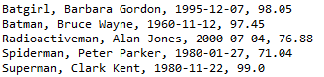

### Part 3

* Get employee_kin.sql from Moodle.
* Import it into MySQL as described in Lab 1.
* Using the employee_kin database, write a JDBC application to print out the Employee Name, Next Of Kin Name, and the Employee Salary of ALL employees on the console as follows:

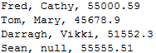

### Part 4

* Get studentDB3.sql from Moodle.
* Import it into MySQL as described in Lab 1.
* Using the studentdb3 database, write a JDBC application to print out
  + the Student Name
  + the Name of the course he/she is doing
  + the name of the college he/she is attending
  + name of the county and
  + main town of the county in which the college is located

on the console as follows:

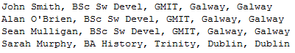

Select s.student_name, c.course_name, col.college_name, col.county, co.county_name

From student_table s

Inner join course_table c

ON s.course_id = c.course_id

Inner join college_table col

On c.college_id = col.college_id

Inner join county_table co

On col.county = co.county_name

The Student Name should be retrieved from the database as *Student*.

The Course Name should be retrieved from the database as *Course*.

The College Name should be retrieved from the database as *Course*.

The County Name should be retrieved from the database as *County*.

The Main Town should be retrieved from the database as *Main Town*.

### Part 5

* Using the solution to Part 2 as a basis for this answer include the following lines of code after you get the connection to the database but before you execute the query:

System.out.println("Press Enter on the Console to Continue");

Scanner sc = new Scanner(System.in);

sc.nextLine();

sc.close();

Now run the program and when the line above is displayed on the console, stop the WAMP server as shown:

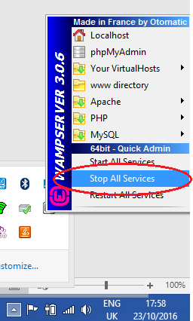

Now when the database cannot be connected to the only error message to be shown on the console should be:

ERROR: Cannot communicate with superheroes database

### Part 6

* Using the solution to Part 5 as a basis for this answer, update it so that instead of doing a query on the superheroes database, the application inserts the following superhero:

Superhero = Joker

Real Name = Jack Nicholson

DOB = March 21st 1949

Powers = 89.4

If the superhero was successfully inserted into the database, the following should be printed on the console:

Joker successfully inserted into database

And the application should be run again trying to insert the same data into the superhero_table. This time an error should be displayed on the console saying:

ERROR: Superhero Joker already exists in database

The success/failure messages should apply to any superhero entered i.e. the names shouldn’t be hard-coded.

### Part 7

* Using the solution to Part 6 as a basis for this answer, update it so that the user is prompted for a superhero name to delete from the database.

Depending on the result from the database the following should be printed:







### Part 8

* Using the solution to Part 7 as a basis for this answer, update it so that the user is asked for a Superhero whose powers will then be increased by 1.

If the superhero was updated successfully his/her new powers should be displayed (having first been read from the database); otherwise an error stating that the superhero does not exist should be printed.





